A8 sync. Writer & Reader

Writer
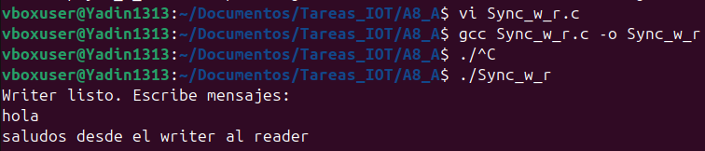

Reader
